**Final Project QMEE**

**Alejandro Rojas**

**Introduction**

The crop establishment is key factor for soybean growers at the beginning of the season where most of the time, seedlings are subject of the attack of soilborne pathogens, resulting in damping off and poor plant establishment. Soybean seedling diseases impact the plant root system at the beginning of the season, however the root infections can occur at later stages, impacting crop physiology and yields. In 2005, seedling diseases caused losses around 829 tons in the US (Wrather & Koenning, 2006). Different factors could influence the outcome of the interaction of soilborne pathogens and soybean plants, such as seed genetic background, the climate, edaphic factors and their interaction with the soil inhabitants (Broders et al., 2009). These soilborne diseases have been attributed to several pathogens most of them fungi and oomycetes (fungi-like organisms). However, the key species playing a role in disease are not fully known (Broders et al., 2007).

In fact, the oomycetes *Pythium* and *Phytophthora* are two of the main causal agents of soybean root diseases, for instance losses have increased by four-fold in the last ten years (Koenning & Wrather, 2010). The increased incidence is related to some of cultural practices now being used by growers, like no-till and early planting. These practices and the environment interact strongly with the microbial communities present in the soil, causing shifts in the different species that exist in this ecosystem (Arcate et al., 2006). The knowledge of the diversity of species causing soybean seedling diseases in the US Midwest is limited. We initially utilized a culture-based approach to start understanding the diversity of oomycetes associated with soybean seedling diseases in the US sampling in 2011 and 2012. A semi-selective medium was selected to increase the recovery rate of a group of organisms, in this case Oomycetes. The identity of the species was confirmed based on the sequencing of Internal Transcribed Spacer (ITS) of the ribosomal DNA.

Oomycetes are known to be aggressive plant pathogens, but the number of species associated with different plant species or different ecosystems is not well known. Recent studies have described multiple new species based on soil and water systems surveys (Kang et al., 2010). Different studies have been done co-relating environmental data with fungal species distribution, resulting on the identification of different drivers such a soil properties and latitude (Tedersoo et al., 2014). However, the relationship of species distribution and environmental factors is undetermined for the oomycetes. The research question focuses on what are the oomycete species associated with soybean seedling diseases. Our hypothesis is that seedling diseases are cause by multiple oomycete species, which some of this species could be acting as pathogen complexes to cause disease across the Midwest. In addition, we also hypothesize that there are climatic and edaphic factors driving the presence and abundance of these oomycetes on the different fields.

The study of the diversity of oomycete pathogens associated to crops like soybean will provide a better understanding of the complexes of organisms that might be associated with disease under specific conditions, for instance climatic and edaphic variables. In order to conduct the analysis different linear models will be evaluated to disentangle the role of different factors on oomycete diversity, also including geographical variables such as latitude to evaluate the hypothesis of diversity on relation to distance from the equator. The understanding of microbial communities associated with soybean will be significant since it is major crop with economical importance not only as staple food, but also as biofuel sources to reduce the impact of potential pathogens, as we understand their distribution, frequency and abundance.

**Methods**

*Sample collection, species ID and climatic data*

Root rot symptomatic soybean seedlings were collected from fields with a history of plant establishment issues and damping-off. A total 50 symptomatic seedlings were collected in W-shaped transect in a field (replication unit). Within a state, 6 fields were sample and a total of 10 to 12 states were sampled in two years 2011 and 2012 (Figure 1). Thus, a hierarchical sampling was conducted collecting plants within single fields within states in the Midwest.

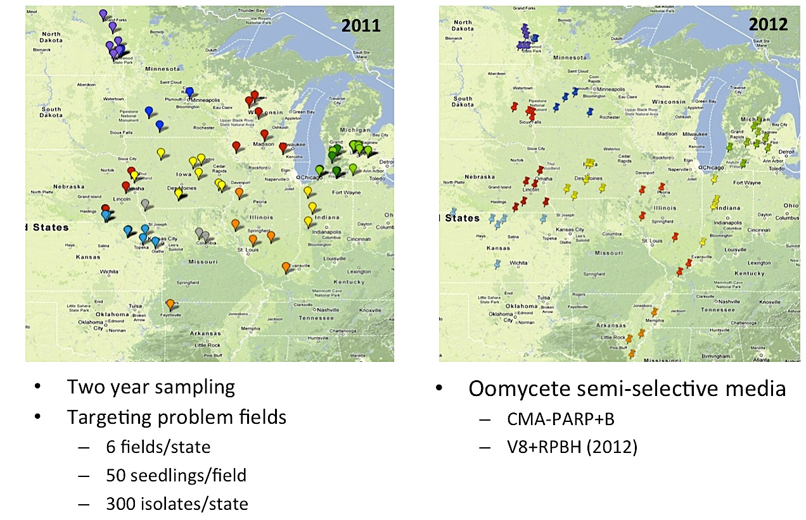

**Figure 1.** Soybean fields sampled across the Midwest during 2011 and 2012.

Symptomatic soybean seedlings were washed with tap water, air-dried and isolations were done placing root tissue on CMA+PARP semi selective media. Plates were incubated at room temperature and visually inspected for hyphal growth after 3 days post isolation. Hyphal tips were transferred to clean media and pure cultures were stored and grown for DNA extraction. DNA extractions were conducted at the genomics center (RTSF – MSU) using a phenol-chloroform automated system (AutoGen Inc., Holliston, MA). Isolates were identified by amplification and sequencing of the Internal Transcribed Spacer (ITS) of the rDNA using primers ITS6 and ITS4 (Cooke et al., 2000). Sequences were assembled using CodonCode Aligner (CodonCode Corp., Dedham, MA, USA) and corroborated against a local database.

Climatic data was collected based GIS coordinates for each sample location and used to query different climatic databases to obtain different environmental parameters.

*Statistical methods*

A dataset was constructed based on number of species identified and diversity indices. In addition, based on latitude and longitude also included in the dataset, climate data such as temperature and precipitation were collected. Data was initially explored to determine the transformation of the data or exclusion of data. The field corresponding to Arkansas collected on 2011 was removed from the data due to issues during data collection since only one field was sampled, and it was oversampled deviating from methods followed in other fields. Parameters that contain quantitative data, such as temperature, precipitation and latitude were centered to reduce possible issues with colinearity. These parameters were centered and added to the data to explore data and construct models. As part of the exploration, plots of different parameters were examined against operational taxonomic units (OTU) or Shannon index.

Statistical methods will help me to understand if there is a pattern across the different states sampled (10 states total) to determine what are (if there is any) difference of community structure across the soybean fields on different states, or if there is different factors that affect the community structure of oomycetes promoting a conducive environment for pathogenic species. Therefore methods on multivariate statistics, correlation of diversity with different factors (e.g. temperature, soil moisture, soil type) will provide some basis on the distribution of these species. If those factors are determined, we can also use to better approach to model the presence of this oomycetes (e.g. general linear model using a reduction of dimensions on my diversity data to compare that to different environmental data) and the risks implied with their presence/abundance also considering their environment.

The null hypothesis for my research question should be that the diversity of oomycetes associated to seedling diseases is not different from has been found at smaller scales, being *P. sojae* the most aggressive and prevalent species. In addition a lack of distinction across the fields sampled. If there are not differences, it would not be possible to determine if there are factors associated with distribution of the species, therefore none of them will be correlated to their presence on the different fields.

**Results**

**Appendix**

Arcate JM, Karp MA, Nelson EB, 2006. Diversity of peronosporomycete (oomycete) communities associated with the rhizosphere of different plant species. *Microbial Ecology* **51**, 36-50.

Broders K, Wallhead M, Austin G*, et al.*, 2009. Association of soil chemical and physical properties with Pythium species diversity, community composition, and disease incidence. *Phytopathology* **99**, 957-67.

Broders KD, Lipps PE, Paul PA, Dorrance AE, 2007. Characterization of *Pythium* spp. Associated with Corn and Soybean Seed and Seedling Disease in Ohio. *Plant Disease* **91**, 727-35.

Cooke DE, Drenth A, Duncan JM, Wagels G, Brasier CM, 2000. A molecular phylogeny of Phytophthora and related oomycetes. *Fungal genetics and biology : FG &amp; B* **30**, 17-32.

Kang S, Mansfield M, Park BB*, et al.*, 2010. The promise and pitfalls of sequence-based identification of plant-pathogenic fungi and oomycetes. *Phytopathology* **100**, 732-7.

Koenning SR, Wrather JA, 2010. Suppression of Soybean Yield Potential in the Continental United States by Plant Diseases from 2006 to 2009. *Plant Health Progress*.

Tedersoo L, Bahram M, Põlme S*, et al.*, 2014. Fungal biogeography. Global diversity and geography of soil fungi. *Science (New York, N.Y.)* **346**, 1256688.

Wrather JA, Koenning SR, 2006. Estimates of disease effects on soybean yields in the United States 2003 to 2005. *Journal of nematology* **38**, 173.